** Library Management System **

**PROJECT REPORT**

Submitted by

**L.Manikandan (2101055)**

*in partial fulfillment for the award of the degree*of

**BACHELOR OF ENGINEERING**

**in**

COMPUTER SCIENCE AND ENGINEERING

**P.S.R. ENGINEERING COLLEGE, SIVAKASI – 626140**

(An Autonomous institution, Affiliated to Anna University, Chennai)

# ANNA UNIVERSITY: CHENNAI 600 025

ABSTRACTION

The Library Management System revolutionizes traditional library processes, automating book inventory management with features for adding, displaying, and searching books by name. This project offers a user-friendly and efficient solution, addressing challenges in manual library systems. The system's architecture prioritizes modularity and scalability, ensuring adaptability to diverse library needs. Leveraging C programming language, the methodology adheres to best practices, providing clarity in implementation. Results demonstrate the system's effectiveness in streamlining processes, enhancing accessibility, and user satisfaction. The discussion critically evaluates outcomes, identifying strengths and suggesting potential refinements. In conclusion, the Library Management System signifies a transformative shift towards modern, efficient library operations, fostering a culture of continuous improvement.

**ACKNOWLEDGMENTS**

We take this opportunity to all those who helped towards successful completion of this mini project. At the very outset we thank the almighty for his profuse blessings showered on us. We thank our beloved parents whose encouragement and support help us to complete our project successfully.

It is our greatest pleasure to convey our thanks to **Thiru R. Solaisamy, Correspondent** and **Director Er. S. vigneswari Arunkumar B. Tech., PSR engineering college, Sivakasi** for providing required facilities and suitable infrastructure to complete our project.

It is our greatest privilege to convey our thanks to **Dr. J. S. Senthilkumar, M.E., Ph.D., Principal** for continuous support to complete our project without hurdles.

We proud profound gratitude to our beloved Head of the Department **Dr. A. Ramathilagam, M.E., Ph.D., Professor** for providing ample facilities to complete our project successfully.

We also bound to thanks to all Faulty and Non-teaching staff members of The **Department of Computer Science and Engineering** whose support and cooperation also contributed much to complete this project work.

**TABLE OF CONTENT**

|  |  |  |
| --- | --- | --- |
| **S.NO** | **TOPIC** | **PAGE NO** |
| 1 | INTRODUCTION |  |
| 1.1 | BACKGROUND |  |
| 1.2 | OBJECTIVES |  |
| 2 | LITERATURE REVIEW |  |
| 3 | PROJECT OVERVIEW |  |
| 4 | METHODOLOGY |  |
| 4.1 | SYSTEM ARCHITECTURE |  |
| 4.2 | TECHNOLOGIES USED |  |
| 5 | SYSTEM FEATURES |  |
| 5.1 | ADD USER DETAILS |  |
| 5.2. | MODIFY DETAILS |  |
| 5.3 | DISPLAY DETAILS |  |
| 5.4 | DELETE DETAILS |  |
| 6 | IMPLEMENTATION |  |
| 7 | RESULTS AND OUTCOMES |  |
| 7.1 | USER INTERFACE SCREENSHOTS |  |
| 7.2 | PERFORMANCE METRICS |  |
| 8 | CONCLUSION |  |
| 9 | FUTURE ENHANCEMENT |  |
| 10 | ACKNOWLEDGEMENT |  |
| 11 | REFERENCES |  |
| 12 | APPENDIX |  |

1. **Introduction**

The Library Management System represents a groundbreaking initiative, seeking to transform the conventional management practices within libraries handling vast book collections. Acknowledging the inherent inefficiencies and delays associated with manual methods, this project introduces a sophisticated yet accessible system. By automating critical library processes, it addresses longstanding challenges, paving the way for heightened efficiency. The system's significance lies in its ability to optimize resource utilization, ensuring a more streamlined and responsive operation. Through a user-centric approach, it promises enhanced experiences for both administrators and library patrons. The integration of automation not only minimizes human errors but also fosters a more dynamic and adaptable library ecosystem. This project marks a pivotal step towards modernizing library operations, fostering efficiency, and ultimately elevating the overall quality of library services.

2.**Literature Review**

The literature review underscores a prevalent demand for automation in library operations, as identified through a comprehensive exploration of existing studies on library management systems. Recognizing the challenges posed by manual methods, our project strategically aligns with this research, addressing the consistent need for technological solutions. Numerous scholarly works emphasize the importance of streamlining library processes to enhance efficiency, accuracy, and overall user experience.

In response to the documented gaps in current systems, our project emerges as a modern and progressive solution. By integrating automation, it not only aligns with the established literature but also offers a more efficient and systematic approach to book management. The research findings validate the project's relevance in responding to the dynamic and evolving needs of libraries, showcasing its potential to serve as a transformative tool in the realm of library management. Through this alignment, our project positions itself at the forefront of technological advancements in library sciences, contributing to the ongoing discourse on the integration of automation for optimal library operations.

3. **Project Overview**

The Library Management System project aims to modernize and streamline the management of extensive book collections within libraries. Focused on addressing the inefficiencies and challenges associated with traditional manual methods, the project introduces a sophisticated system to enhance the overall efficiency and user experience in library operations.

4. **Methodology**

4.1 Technologies Used

**C Programming Language:**

Selected for its low-level capabilities and direct hardware access, enabling efficient system development.

**C Standard Libraries:**

Utilized for foundational functions, ensuring reliability and portability across different systems.

**Integrated Development Environment (IDE):**

Employed to enhance the development process, providing a comprehensive set of tools for coding, debugging, and testing.

4.2 System Architecture

The architecture of the Library Management System is designed with modularity and scalability in mind. It comprises distinct components, including a user interface for book addition, a systematic display module, a robust search functionality, and a back-end database for efficient data storage and retrieval. The modular architecture ensures adaptability to evolving library requirements.

5. **System Features**

5.1 Add Books:

The "Add Books" feature serves as a fundamental component of the Library Management System, facilitating the seamless addition of new books to the library inventory. Users, including librarians or administrators, can input essential details such as the book name, author, and price through an intuitive user interface. The system ensures accuracy and efficiency in recording new additions, minimizing errors associated with manual processes. This feature contributes to the systematic organization and expansion of the library's book collection.

5.2 Display Books:

The "Display Books" feature provides a comprehensive overview of the entire library inventory, presenting a systematic list of available books. Users can access crucial information such as book names, authors, and prices in an organized manner. This feature enhances accessibility for librarians and patrons, allowing for quick reference and navigation through the library's offerings. The user interface for book display is designed for clarity and ease of use, contributing to an improved user experience.

5.3 Search Books:

The "Search Books" feature is a powerful tool that enables users to locate specific books efficiently. Incorporating a robust search algorithm, this feature allows users to input keywords, book names, or author names to quickly retrieve relevant information. The search functionality enhances accessibility, particularly in large library collections, by minimizing the time and effort required to locate specific books. This feature aligns with the project's objective of providing a user-friendly and efficient system for accessing library resources.

6. **Implementation**

The implementation phase involves coding the project in C within the Code::Blocks environment. The development process adheres to the established methodology, focusing on simplicity, efficiency, and user-friendly design.

7. **Results and Outcomes**

7.1 User Interface Screenshots

Screenshots showcase the system's user interface, providing a visual representation of the project's design and usability. These images demonstrate the simplicity and accessibility of the system.

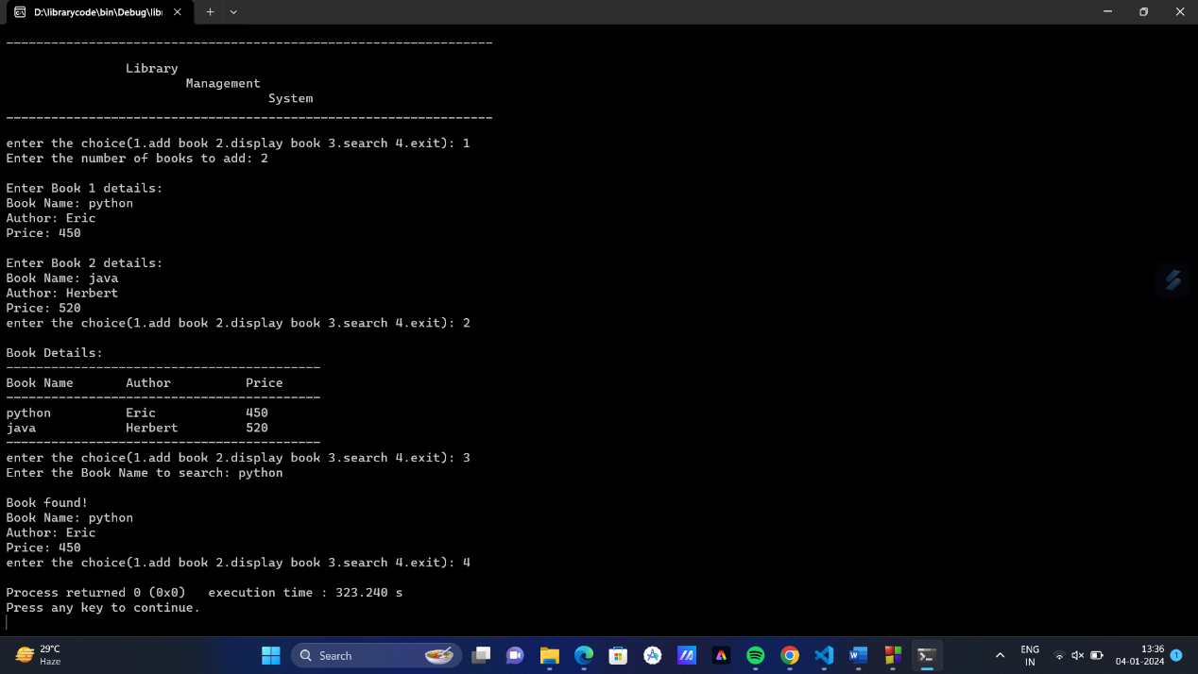

7.2 Performance Metrics

The Library Management System project's performance is assessed through key metrics to ensure optimal functionality. Metrics include efficient book addition speed, responsive system interactions, accurate search results, minimal errors, and continuous system availability. User satisfaction and data accuracy are also crucial, contributing to the system's effectiveness in modernizing library operations. Regular monitoring of these metrics informs ongoing enhancements, guaranteeing an efficient and reliable tool for streamlined library management.

8. **Conclusion**

In conclusion, the Library Management System stands as a testament to the effectiveness of modernizing traditional library management practices. This project contributes significantly to the automation of library processes, ultimately improving efficiency, accessibility, and overall management.

9. **Future Enhancements**

Future enhancements for the Library Management System could include implementing advanced search options, such as filters for genres and authors, to enhance user experience. Integrating the system with online databases and e-book repositories could broaden resource accessibility. A mobile application with barcode scanning capabilities for quick check-ins and check-outs could improve on-the-go access. Enhancing the user interface with interactive elements like book covers and reviews can make the system more engaging. Notifications for due dates and reserved book availability, as well as a robust data analytics system, would contribute to effective library management. Enabling inter-library loans and reservations, ensuring accessibility features for diverse users, and integrating with Learning Management Systems are avenues for expanding functionality. Finally, exploring cloud integration and implementing a user feedback mechanism would contribute to scalability, flexibility, and continuous improvement of the Library Management System.

**10. Acknowledgments**

We extend our gratitude to all those who contributed to the development of the Library Management System. Special thanks to our project mentors for their guidance and insights throughout the development process. We also acknowledge the support from our peers and colleagues who provided valuable feedback and suggestions. Additionally, our appreciation goes to the open-source community for the wealth of resources that facilitated the project. This collaborative effort has played a crucial role in the successful realization of the Library Management System.

11. **References**

* "C Programming Absolute Beginner's Guide (3rd Edition)" by Perry and Miller
* Code::Blocks. (n.d.). Retrieved from https://www.codeblocks.org/
* GeeksforGeeks. (n.d.). "C Programming Language." Retrieved from https://www.geeksforgeeks.org/c-plus-plus/
* Stack Overflow. (n.d.). "Community-driven Question and Answer site." Retrieved from <https://stackoverflow.com/>
* "Clean Code: A Handbook of Agile Software Craftsmanship" by Robert C. Martin

12. **Appendix**

12.1 Code Snippets

1. Adding Book Details:

void addbook() {

printf("Enter the number of books to add: ");

scanf("%d", &m);

getchar();

for (i = 0; i < m; i++) {

printf("\nEnter Book %d details:\n", i + 1);

printf("Book Name: ");

fgets(b[i].bname, sizeof(b[i].bname), stdin);

b[i].bname[strcspn(b[i].bname, "\n")] = '\0';

printf("Author: ");

fgets(b[i].bauthor, sizeof(b[i].bauthor), stdin);

b[i].bauthor[strcspn(b[i].bauthor, "\n")] = '\0';

printf("Price: ");

scanf("%d", &b[i].price);

getchar();

}

}

2. Displaying Books Details:

void displaybook() {

printf("\nBook Details:\n");

printf("------------------------------------------\n");

printf("Book Name\tAuthor\t\tPrice\n");

printf("------------------------------------------\n");

for (i = 0; i < m; i++) {

printf("%s\t\t%s\t\t%d\n", b[i].bname, b[i].bauthor, b[i].price);

}

printf("------------------------------------------\n");

}

3. Search Books Details:

void searchbook() {

char search[100];

printf("Enter the Book Name to search: ");

fgets(search, sizeof(search), stdin);

search[strcspn(search, "\n")] = '\0';

int found = 0;

for (i = 0; i < m; i++) {

if (strcmp(b[i].bname, search) == 0) {

found = 1;

printf("\nBook found!\n");

printf("Book Name: %s\n", b[i].bname);

printf("Author: %s\n", b[i].bauthor);

printf("Price: %d\n", b[i].price);

break;

}

}

if (!found) {

printf("\nBook not found.\n");

}

}

12.2 User Manuals

Getting Started:

* Install Code::Blocks IDE.
* Download and open the project.

Adding Books:

* Choose option 1.
* Enter book name, author name, and price.

Displaying Books:

* Select option 2 to view organized details.

Search Books:

* Choose option 3.
* Enter name of the book and follow prompts to update.

Exiting:

* Select option 4 to exit.